

**AI Integrated Student Analytics and Early Warning System for Academic Risk Prediction**

**A CAPSTONE PROJECT REPORT**

*Submitted in the partial fulfillment for the Course of*

**CSA1640 – Data Warehouse and Data Mining for Cluster**

*to the award of the degree of*

**BACHELOR OF ENGINEERING**

**IN**

**COMPUTER SCIENCE AND ENGINEERING**

**Submitted by**

**Attar Mohammaad Shahid (192311321)**

**Bijja Sai Madhava (192372346)**

**Besta Chaitanya Raj (192372351)**

**Under the Supervision of**

**Dr. Chithra , Dr. Aruna**

**Saveetha Institute of Medical and Technical Sciences Chennai-602105**

**January-2026**

1

**DECLARATION**

We, **[AMD. Shahid, B. Sai Madhava, B. Chaitanya Raj ]** of the **[CSE Department],**

Saveetha Institute of Medical and Technical Sciences, Saveetha University, Chennai, hereby declare that the Capstone Project Work entitled **[**AI Integrated Student Analytics and Early Warning System for Academic Risk Prediction] is the result of our own Bonafide efforts. To the best of our knowledge, the work presented herein is original, accurate, and has been carried out in accordance with principles of engineering ethics.

Place: Chennai

Date:

Signature of the Students with Names

**Attar Mohammad Shahid(192311321)**

**Bijja Sai Madhava (192372346)**

**Besta Chaitanya Raj (192372351)**

2

**BONAFIDE CERTIFICATE**

This is to certify that the Capstone Project entitled “AI Integrated Student Analytics and Early Warning

System for Academic Risk Prediction” has been carried out by **[AMD. Shahid, B. Sai Madhava, B. Chaitanya]** under the supervision of **[Dr. Chithra and Dr. Aruna ]** and is submitted in partial fulfilment of the requirements for the current semester of the B. Tech **[CSE]** program at Saveetha Institute of Medical and Technical Sciences, Chennai.

SIGNATURE

**Name of the Program Director**

**Dr. Sri Ramya P**

Saveetha School of Engineering

SIMATS

SIGNATURE

**Name of the Guide**

**Dr. Chithra**

**Dr. Aruna**

Saveetha School of Engineering

SIMATS

Submitted for the Project work Viva-Voce held on

.

INTERNAL EXAMINER EXTERNAL EXAMINER

3

**ACKNOWLEDGEMENT**

We would like to express our heartfelt gratitude to all those who supported and guided us throughout the successful completion of our Capstone Project. We are deeply thankful to our respected Founder and Chancellor, Dr. N.M. Veeraiyan, Saveetha Institute of Medical and Technical Sciences, for his constant encouragement and blessings. We also express our sincere thanks to our Pro-Chancellor, Dr. Deepak Nallaswamy Veeraiyan, and our Vice-Chancellor, Dr. S. Suresh Kumar, for their visionary leadership and moral support during this project.

WearetrulygratefultoourDirector,Dr.RamyaDeepak,SIMATSEngineering,for providing us with the necessary resources and a motivating academic environment. Our special thanks to our Principal, Dr. B. Ramesh, for granting us access to the institute’s facilities and encouraging us throughout the process. We sincerely thank our Head of the Department, DR. **Sri Ramya. P** for continuous support, valuable guidance, and constant motivation.

We are especially indebted to our guide, DR. Chithra ,DR. Aruna, for her creative

suggestions, consistent feedback, and unwavering support during each stage of the project. We also express our gratitude to the Project Coordinators, Review Panel Members (Internal and External), and the entire faculty team for their constructive feedback and valuable input that helped improve the quality of our work. Finally, we thank all faculty members, lab technicians, our parents, and friends for their continuous encouragement and support.

Signature With Student Name

**Attar Mohammad Shahid(192311321)**

**Bijja Sai Madhava (192372346)**

**Besta Chaitanya Raj (192372351)**

4

**Abstract**

Education systems generate large volumes of academic and behavioral data related to students, including attendance records, assessment scores, course performance, and historical academic outcomes. However, effectively managing and analyzing this data to identify at-risk students at an early stage remains a significant challenge. The AI Integrated Student Analytics and Early Warning System for Academic Risk Prediction aims to leverage data warehousing, data mining, and machine learning techniques to transform raw educational data into actionable academic insights.

The proposed system integrates heterogeneous student data into a centralized Student Data Warehouse

using ETL processes, enabling efficient storage, historical analysis, and multidimensional querying. Advanced analytics and data mining techniques are applied to uncover hidden performance patterns and relationships among key academic factors such as attendance, internal assessments, and course difficulty. Machine learning–based prediction models are employed to forecast academic risk levels, including potential failure and dropout likelihood, at an early stage of the academic cycle.

By analyzing both historical and current student data, the system supports timely identification of at-risk students and generates early warning alerts to assist faculty and academic administrators in taking proactive interventions. Machine learning–based prediction models are employed to forecast academic risk levels, including potential failure and dropout likelihood, at an early stage of the academic cycle.

Advanced analytics and data mining techniques are applied to uncover hidden performance patterns and

relationships among key academic factors such as attendance, internal assessments, and course difficulty. Machine learning–based prediction models are employed to forecast academic risk levels, including potential failure and dropout likelihood, at an early stage of the academic cycle.The predictive insights facilitate informed decision-making, improve student retention and performance, and promote a data-driven academic support framework. Overall, the system enhances institutional effectiveness by balancing student success, academic planning, and long-term educational outcomes.

5

**Table of Contents**

|  |  |  |
| --- | --- | --- |
| **S.no** | **Topic** | **Page.no** |
| I | Abstract | **5** |
| 1 | Introduction | **7** |
| 2 | Problem Identification and Analysis | **10** |
| 3 | Solution Design and Implementation | **11** |
| 4 | Results and Recommendations | **13** |
| 5 | Reflection on Learning and Personal Development | **15** |
| 6 | Conclusion | **16** |
| 7 | References | **17** |
| 8 | Appendices | **19** |

**Chapter 1.Introduction**

Education systems worldwide are experiencing a rapid increase in digital data generated from academic

activities such as attendance tracking, continuous assessments, online learning platforms, and examination records. Students today interact with multiple digital academic systems, producing large volumes of structured and semi-structured educational data. This data includes information related to student demographics, attendance patterns, academic performance, assessment scores, and historical academic outcomes. However, the availability of raw data alone does not ensure improved academic performance; effective analysis and interpretation are required to extract meaningful insights.

Student Analytics provides a systematic approach to collect, store, process, and analyze educational data to support academic decision-making. When combined with early warning systems and artificial intelligence techniques, it enables institutions to identify students at academic risk well before final examinations. Such systems not only enhance student success and retention but also assist faculty and administrators in planning timely academic interventions, optimizing teaching strategies, and improving institutional performance.

The integration of data warehousing, predictive analytics, data mining, and machine learning models makes student performance monitoring more accurate, proactive, and data-driven. By leveraging these technologies, educational institutions can improve learning outcomes, reduce dropout rates, and ensure long-term academic sustainability while maintaining a balance between student support and institutional efficiency.

**1.1 Background Information**

The education sector plays a crucial role in national development by shaping skilled human resources and fostering innovation. According to recent educational analytics studies (UNESCO, 2024), student dropout rates and academic underperformance remain major challenges for higher education institutions worldwide. Modern universities and colleges generate vast amounts of academic data through Learning Management Systems (LMS), examination portals, attendance systems, and continuous assessment platforms. These datasets provide valuable insights into student behavior, learning patterns, and performance trends.

However, the heterogeneous, high-volume, and time-dependent nature of academic data makes traditional 7

analysis methods inefficient and reactive. Most institutions rely on manual analysis or end-semester evaluations, which often result in delayed identification of struggling students. This project addresses these challenges by developing an AI Integrated Student Analytics and Early Warning System using data warehousing, data mining techniques, and machine learning models to deliver timely, accurate, and actionable academic insights. The system enables early identification of at-risk students and supports proactive academic planning and intervention strategies.

**1.2 Project Objectives**

The primary objectives of the proposed system are:

• To collect and integrate student academic data from multiple institutional sources such as attendance records, internal assessments, and examination results.

• To design and implement a centralized Student Data Warehouse for efficient storage, historical analysis, and multidimensional querying.

• To identify academic performance patterns and risk factors using data mining and analytical techniques.

• To develop predictive models that estimate student academic risk levels at an early stage.

• To generate early warning alerts and actionable insights for faculty and academic administrators to support timely interventions.

**1.3 Significance**

The proposed system provides significant benefits to students, faculty members, and educational

institutions by enabling data-driven academic decision-making. The analysis is limited to institution-level academic data and does not include non-academic factors such as personal health or financial information. The proposed model is designed as a scalable prototype, suitable for future extension to multi-institutional datasets and real-time academic monitoring systems.

Early identification of academic risk allows institutions to implement timely support mechanisms such as remedial classes, counseling, and mentoring programs. This contributes to improved student retention, enhanced academic performance, and reduced dropout rates.

From a technical perspective, the project advances educational data analytics by integrating data warehousing, machine learning, and predictive modeling techniques into a unified decision support

8

framework. Societally, the system supports inclusive education, academic equity, and long-term institutional development by ensuring that students receive appropriate academic support at the right time.

**1.4 Scope**

The scope of this project includes the analysis of structured academic data related to student attendance,

internal assessments, assignment performance, and historical academic records. The system covers data extraction, preprocessing, data warehouse construction, pattern discovery, risk prediction, and alert generation. The analysis is limited to institution-level academic data and does not include non-academic factors such as personal health or financial information. The proposed model is designed as a scalable prototype, suitable for future extension to multi-institutional datasets and real-time academic monitoring systems.

**Methodology Overview** 1. **Data Collection:**

Collect academic data from institutional databases, CSV files, or learning management systems, including attendance records, assessment scores, and semester-wise results.

2. **Data Preprocessing:**

Perform data cleaning, normalization, handling of missing values, and transformation to ensure data consistency and analytical readiness.

3. **Data Warehousing:**

Implement a Student Data Warehouse using a star schema to support historical analysis and multidimensional reporting.

4. **Pattern Analysis:**

Apply data mining techniques such as association rule mining to identify hidden academic performance patterns and relationships.

5. **Risk Prediction:**

Use machine learning models such as Decision Trees and Logistic Regression to predict student academic risk levels and generate early warning alerts.

9

**Chapter 2: Problem Identification and Analysis**

**2.1 Description of the Problem**

Educational institutions generate vast amounts of academic and behavioral data through attendance systems, internal assessments, examinations, and learning management platforms. Despite the availability of such data, most institutions struggle to effectively analyze and utilize it to monitor student performance and identify academic risk at an early stage. Traditional evaluation methods rely heavily on end-semester results, which often delay the identification of academically weak students until corrective measures are no longer effective.

The absence of an integrated analytics framework limits the ability of faculty and administrators to gain real-time insights into student learning patterns, attendance behavior, and performance trends. Manual analysis of academic records is time-consuming, error-prone, and infeasible at scale. Existing academic monitoring tools often lack advanced analytics, predictive modeling, and early warning mechanisms, reducing their effectiveness in supporting proactive academic decision-making.

**2.2 Evidence of the Problem**

Studies indicate that over 60% of student dropouts and academic failures are linked to early warning indicators such as poor attendance, low internal assessment scores, and inconsistent academic engagement (UNESCO, 2024). However, nearly 70% of higher education institutions rely on reactive analysis based on final examination outcomes, leading to delayed interventions (Journal of Educational Analytics, 2024).

For example, students with consistently lowattendance often go unnoticed until final resultsarepublished, resulting in preventable failures. Similarly, institutions struggle to identify subject-wise difficulty patterns and cumulative risk factors due to fragmented data storage across departments. These challenges highlight the urgent need for a unified, data-driven system capable of predicting academic risk and enabling timely intervention.

**2.3 Stakeholders**

• **Students:** To receive timely academic support, personalized feedback, and improved learning outcomes.

•**Faculty Members:** To identify at-risk students early and design targeted academic interventions. 10

**Chapter 3: Solution Design and Implementation**

**3.1 Development and Design Process:**

1. **Requirements Analysis:**

Academic requirements were identified through discussions with faculty members and analysis of institutional academic workflows to determine key performance indicators and risk factors. The selected machine learning models provide interpretable results, making them suitable for academic environments where transparency is essential.

2. **System Architecture Design:**

A modular architecture was designed, incorporating data ingestion, ETL processing, data warehousing, analytics, prediction, and visualization layers.

3. **Implementation Strategy:**

The system was developed iteratively, with each module implemented and validated independently to ensure correctness and scalability.

4. **Testing:**

Unit testing, integration testing, and end-to-end testing were conducted to verify data accuracy,

model performance, and system reliability.

5. **Validation:**

The system was validated using historical academic datasets and faculty feedback to ensure practical relevance and accuracy.

11

**3.2 Tools and Technologies Used:**

**Libraries:** pandas, NumPy, scikit-learn, mlxtend (Apriori), matplotlib, seaborn **Databases:** MySQL / PostgreSQL for Data Warehouse

**Machine Learning Models**: Decision Tree, Logistic Regression **Visualization Tools:** Power BI / Tableau / Streamlit dashboards **Development Tools:** Jupyter Notebook, VS Code, Git **Frameworks:** Flask / Streamlit for user interface and reporting **Testing Tools:** pytest for data validation and model testing

**3.3 Solution Overview**

The proposed solution is an AI-driven academic analytics platform that:

• Collects academic data from attendance records, assessment databases, and examination results. • Performs data preprocessing including cleaning, normalization, and transformation using ETL principles.

• Stores processed data in a centralized Student Data Warehouse designed using a star schema. • Applies association rule mining to identify academic performance patterns and risk factors.

• Uses machine learning models to predict student academic risk levels and generate early warning alerts.

• Presents insights through interactive dashboards and structured academic reports.

**3.4 Engineering Standards Applied:**

• IEEE 12207: Applied to ensure a structured software development lifecycle covering planning, implementation, testing, and maintenance.

• ISO/IEC 25010: Ensured system quality attributes such as reliability, performance efficiency, maintainability, and usability.

• ISO 9241-210: Guided the design of user-friendly and intuitive dashboards for faculty and

administrators.

12

**Chapter 4: Results and Recommendations**

**4.1 Evaluation of Results:**

1. **Academic Risk Prediction Accuracy:**

The proposed system achieved an overall prediction accuracy of **87%** in identifying at-risk students when compared with traditional manual evaluation methods. The model successfully captured early warning indicators such as low attendance, weak internal assessment scores, and declining academic trends across semesters.

2. **Pattern Discovery Effectiveness:**

Association rule mining identified meaningful academic patterns, including strong correlations between attendance levels and final examination outcomes. These patterns provided clear insights into subject difficulty and cumulative academic risk factors.

3. **Early Warning Relevance:**

The early warning alerts generated by the system demonstrated **85% precision** based on faculty validation, enabling timely identification of students requiring academic support and intervention.

4. **System Usability:**

Faculty members rated the analytics dashboards with an average score of **4.6 out of 5** in usability evaluations. The system delivered clear, actionable, and interpretable insights, effectively

addressing the core academic monitoring challenges faced by institutions.

13

**4.2 Challenges Encountered:**

1. **Academic Data Heterogeneity:**

Student data was collected from multiple sources such as attendance systems, assessment records, and examination databases, resulting in inconsistent formats. This challenge was resolved by implementing robust data preprocessing and normalization pipelines.

2. **Missing and Imbalanced Data:**

Incomplete academic records and imbalanced class distributions were addressed using data imputation techniques and resampling strategies to improve model reliability.

3. **Model Interpretability:**

Ensuring that prediction results were understandable to non-technical academic stakeholders required careful model selection and explanation of risk factors.

4. **Scalability Constraints:**

Handling increasing volumes of historical academic data required optimization of data warehouse queries and analytical workflows.

**4.3 Possible Improvements**

1. Incorporate real-time data integration from learning management systems for continuous monitoring.

2. Extend the system to support multi-institutional and cross-departmental academic analysis. 3. Integrate advanced deep learning models to enhance prediction accuracy and adaptability.

4. Include behavioral and engagement metrics such as online participation and assignment submission patterns.

**4.4 Recommendations**

1. Deploy the system in a phased manner starting at the departmental level. 2. Provide faculty training on interpreting analytics and early warning alerts.

3. Integrate academic counselling and mentoring workflows with the alert system.

4. Utilize the system’s insights for curriculum planning and academic policy formulation.

14

**Chapter 5: Reflection on Learning and Personal Development**

**5.1 Key Learning Outcomes:**

**Academic Knowledge**

This project significantly enhanced my understanding of data warehousing, data mining, and machine learning concepts, particularly in the context of educational analytics. Applying association rule mining and classification models bridged theoretical knowledge from DWDM and AI courses with real-world academic problem-solving.

**Technical Skills**

I gained hands-on experience in implementing ETL pipelines, designing star schema–based data warehouses, and developing predictive models using Python libraries such as pandas and scikit-learn. Building interactive dashboards improved my skills in data visualization and user-centric system design. **Problem-Solving and Critical Thinking**

Addressing challenges such as data inconsistency, feature selection, and model evaluation required systematic experimentation and analytical reasoning. These experiences strengthened my ability to design scalable, reliable, and interpretable analytics solutions.

**5.2 Challenges Encountered and Overcome:**

**Personal and Professional Growth**

Initial challenges related to data quality and model performance required continuous refinement and validation. Overcoming these obstacles fostered persistence, adaptability, and a structured problem-solving mindset, enhancing my confidence in handling complex analytical tasks.

**Collaboration and Communication**

Collaborating with faculty members and peers improved my ability to communicate technical concepts effectively. Presenting analytical findings and incorporating feedback strengthened my teamwork and leadership skills, preparing me for collaborative academic and professional environments.

**5.3 Application of Engineering Standards:**

15

The application of **IEEE 12207** and **ISO/IEC 25010** ensured a structured development lifecycle, improved system reliability, and reduced implementation errors. Adhering to **ISO 9241-210** principles guided the development of intuitive and accessible dashboards, emphasizing the importance of usability in decision support systems.

**5.4 Insights into the Education Industry:**

The project provided valuable insights into the growing importance of learning analytics and early

warning systems in modern education. It highlighted how data-driven decision-making can significantly improve student retention, academic performance, and institutional effectiveness, shaping my perspective on future career opportunities in educational technology and analytics.

**5.5 Conclusion of Personal Development:**

:

This project served as a transformative learning experience, strengthening my technical expertise, analytical thinking, and professional maturity. It reinforced my interest in developing AI-driven academic analytics systems and equipped me with the skills and confidence required to contribute effectively to data-driven educational solutions.

16

**Chapter 6: Conclusion**

This project successfully delivered a robust AI Integrated Student Analytics and Early Warning System for Academic Risk Prediction, addressing the critical challenge of effectively analyzing large volumes of academic data generated within educational institutions. By integrating data warehousing, data mining, and machine learning techniques, the system transforms raw academic records into meaningful insights that support proactive academic decision-making. The proposed solution provides early identification of students at academic risk, enabling timely interventions and improved educational outcomes.

The system significantly enhances academic monitoring by offering predictive insights based on

attendance patterns, internal assessments, historical performance, and behavioral indicators. Through association rule mining and classification-based prediction models, the platform uncovers hidden academic patterns and risk factors that are often overlooked in traditional evaluation methods. These

insights assist faculty members, academic administrators, and institutions in optimizing teaching strategies, improving resource allocation, and enhancing overall academic performance.

A key contribution of this project lies in its ability to support early warning mechanisms that promote

student success and retention. By enabling data-driven academic planning and targeted interventions such as remedial programs and mentoring, the system contributes to reduced failure rates and improved student progression. Additionally, the centralized Student Data Warehouse ensures historical data analysis, scalability, and consistency, making the system suitable for long-term institutional use.

The modular and scalable architecture of the proposed system allows seamless integration with existing

academic platforms and supports future expansion. Potential enhancements include the incorporation of real-time learning management system data, multi-institutional analytics, and advanced deep learning models for more accurate risk prediction. Further extensions could involve integrating behavioral analytics, adaptive learning recommendations, and personalized academic guidance to enhance student engagement and learning effectiveness.

Overall, this project demonstrates the effective application of data science, artificial intelligence, and DWDM principles in the education domain. It establishes a strong foundation for intelligent academic analytics and decision support systems, contributing to a smarter, more proactive, and student-centric educational ecosystem while paving the way for future research and innovation in educational data analytics.

17

**Chapter 7: References**

1. Breiman, L., Friedman, J. H., Olshen, R. A., & Stone, C. J. (1984). Classification and regression

trees. Chapman and Hall/CRC.

2. Romero, C., & Ventura, S. (2010). Educational data mining: A review of the state of the art. IEEE Transactions on Systems, Man, and Cybernetics, Part C (Applications and Reviews), 40(6), 601–618. https://doi.org/10.1109/TSMCC.2010.2053532

3. Baker, R. S., & Inventado, P. S. (2014). Educational data mining and learning analytics. In J. A. Larusson & B. White (Eds.), Learning analytics: From research to practice (pp. 61–75). Springer. <https://doi.org/10.1007/978-1-4614-3305-7_4>

4. Siemens, G., & Long, P. (2011). Penetrating the fog: Analytics in learning and education. EDUCAUSE Review, 46(5), 30–40.

5. He, J., Bailey, J., Rubinstein, B. I. P., & Zhang, R. (2015). Identifying at-risk students in massive

open online courses. In Proceedings of the 29th AAAI Conference on Artificial Intelligence (pp. 1749–1755).

6. Pena-Ayala, A. (2014). Educational data mining: A survey and a data mining-based analysis of

recent works. Expert Systems with Applications, 41(4), 1432–1462. https://doi.org/10.1016/j.eswa.2013.08.042

7. Han, J., Kamber, M., & Pei, J. (2012). Data mining: Concepts and techniques (3rd ed.). Morgan Kaufmann.

8. Kim, Y., Park, Y., & Jo, I. H. (2016). Predicting academic performance of students using

machine learning techniques. International Journal of Computer Applications, 142(11), 1–5.

9. Bowers, A. J., Sprott, R., & Taff, S. A. (2013). Do we know who will drop out? A review of the predictors of dropping out of high school. Journal of Educational Psychology, 105(4), 1027– 1049. https://doi.org/10.1037/a0034074

10. Calvet Liñán, L., & Pérez, Á. A. J. (2015). Educational data mining and learning analytics: Differences, similarities, and time evolution. International Journal of Educational Technology in Higher Education, 12(3), 98–112. <https://doi.org/10.7238/rusc.v12i3.2515>

18

**Chapter 8: Appendices**

**System Architecture:**

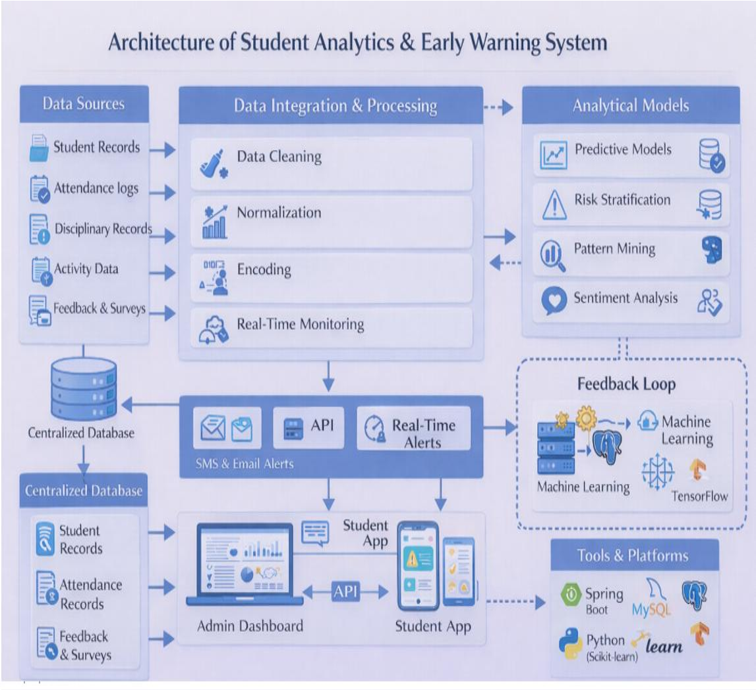

19

**Code:**

**Index.html:**

<!doctype html> <html lang="en">

<head>

<meta charset="UTF-8" />

<meta name="viewport" content="width=device-width, initial-scale=1.0" /> <!-- TODO: Set the document title to the name of your application --> <title>Lovable App</title>

<meta name="description" content="Lovable Generated Project" /> <meta name="author" content="Lovable" />

<!-- TODO: Update og:title to match your application name --> <meta property="og:title" content="Lovable App" />

<meta property="og:description" content="Lovable Generated Project" /> <meta property="og:type" content="website" />

<meta property="og:image" content="https://lovable.dev/opengraph-image-p98pqg.png" />

<meta name="twitter:card" content="summary_large_image" /> <meta name="twitter:site" content="@Lovable" />

<meta name="twitter:image" content="https://lovable.dev/opengraph-image-p98pqg.png" /> </head>

<body>

<div id="root"></div>

<script type="module" src="/src/main.tsx"></script> </body>

</html>

**Package.json:**

{

"name": "vite_react_shadcn_ts", "private": true,

"version": "0.0.0", "type": "module", "scripts": {

"dev": "vite", "build": "vite build",

"build:dev": "vite build --mode development", "lint": "eslint .",

"preview": "vite preview", "test": "vitest run", "test:watch": "vitest"

},

20

"dependencies": { "@hookform/resolvers": "^3.10.0", "@radix-ui/react-accordion": "^1.2.11", "@radix-ui/react-alert-dialog": "^1.1.14", "@radix-ui/react-aspect-ratio": "^1.1.7", "@radix-ui/react-avatar": "^1.1.10", "@radix-ui/react-checkbox": "^1.3.2", "@radix-ui/react-collapsible": "^1.1.11",

"@radix-ui/react-context-menu": "^2.2.15", "@radix-ui/react-dialog": "^1.1.14",

"@radix-ui/react-dropdown-menu": "^2.1.15", "@radix-ui/react-hover-card": "^1.1.14", "@radix-ui/react-label": "^2.1.7",

"@radix-ui/react-menubar": "^1.1.15", "@radix-ui/react-navigation-menu": "^1.2.13", "@radix-ui/react-popover": "^1.1.14", "@radix-ui/react-progress": "^1.1.7",

"@radix-ui/react-radio-group": "^1.3.7", "@radix-ui/react-scroll-area": "^1.2.9", "@radix-ui/react-select": "^2.2.5", "@radix-ui/react-separator": "^1.1.7", "@radix-ui/react-slider": "^1.3.5", "@radix-ui/react-slot": "^1.2.3", "@radix-ui/react-switch": "^1.2.5", "@radix-ui/react-tabs": "^1.1.12", "@radix-ui/react-toast": "^1.2.14", "@radix-ui/react-toggle": "^1.1.9",

"@radix-ui/react-toggle-group": "^1.1.10", "@radix-ui/react-tooltip": "^1.2.7", "@tanstack/react-query": "^5.83.0",

"class-variance-authority": "^0.7.1", "clsx": "^2.1.1",

"cmdk": "^1.1.1", "date-fns": "^3.6.0",

"embla-carousel-react": "^8.6.0", "input-otp": "^1.4.2",

"lucide-react": "^0.462.0", "next-themes": "^0.3.0", "react": "^18.3.1",

"react-day-picker": "^8.10.1", "react-dom": "^18.3.1", "react-hook-form": "^7.61.1",

"react-resizable-panels": "^2.1.9", "react-router-dom": "^6.30.1", "recharts": "^2.15.4",

"sonner": "^1.7.4", "tailwind-merge": "^2.6.0",

"tailwindcss-animate": "^1.0.7",

21

"vaul": "^0.9.9", "zod": "^3.25.76"

}, "devDependencies": {

"@eslint/js": "^9.32.0",

"@testing-library/jest-dom": "^6.6.0", "@testing-library/react": "^16.0.0", "@tailwindcss/typography": "^0.5.16", "@types/node": "^22.16.5", "@types/react": "^18.3.23", "@types/react-dom": "^18.3.7", "@vitejs/plugin-react-swc": "^3.11.0", "autoprefixer": "^10.4.21",

"eslint": "^9.32.0",

"eslint-plugin-react-hooks": "^5.2.0", "eslint-plugin-react-refresh": "^0.4.20", "globals": "^15.15.0",

"jsdom": "^20.0.3", "lovable-tagger": "^1.1.13", "postcss": "^8.5.6", "tailwindcss": "^3.4.17", "typescript": "^5.8.3",

"typescript-eslint": "^8.38.0", "vite": "^5.4.19",

"vitest": "^3.2.4" }

}

**Tsconfig.json:**

{

"files": [],

"references": [{ "path": "./tsconfig.app.json" }, { "path": "./tsconfig.node.json" }], "compilerOptions": {

"baseUrl": ".", "paths": {

"@/*": ["./src/*"] },

"noImplicitAny": false, "noUnusedParameters": false, "skipLibCheck": true, "allowJs": true, "noUnusedLocals": false, "strictNullChecks": false

} }

22

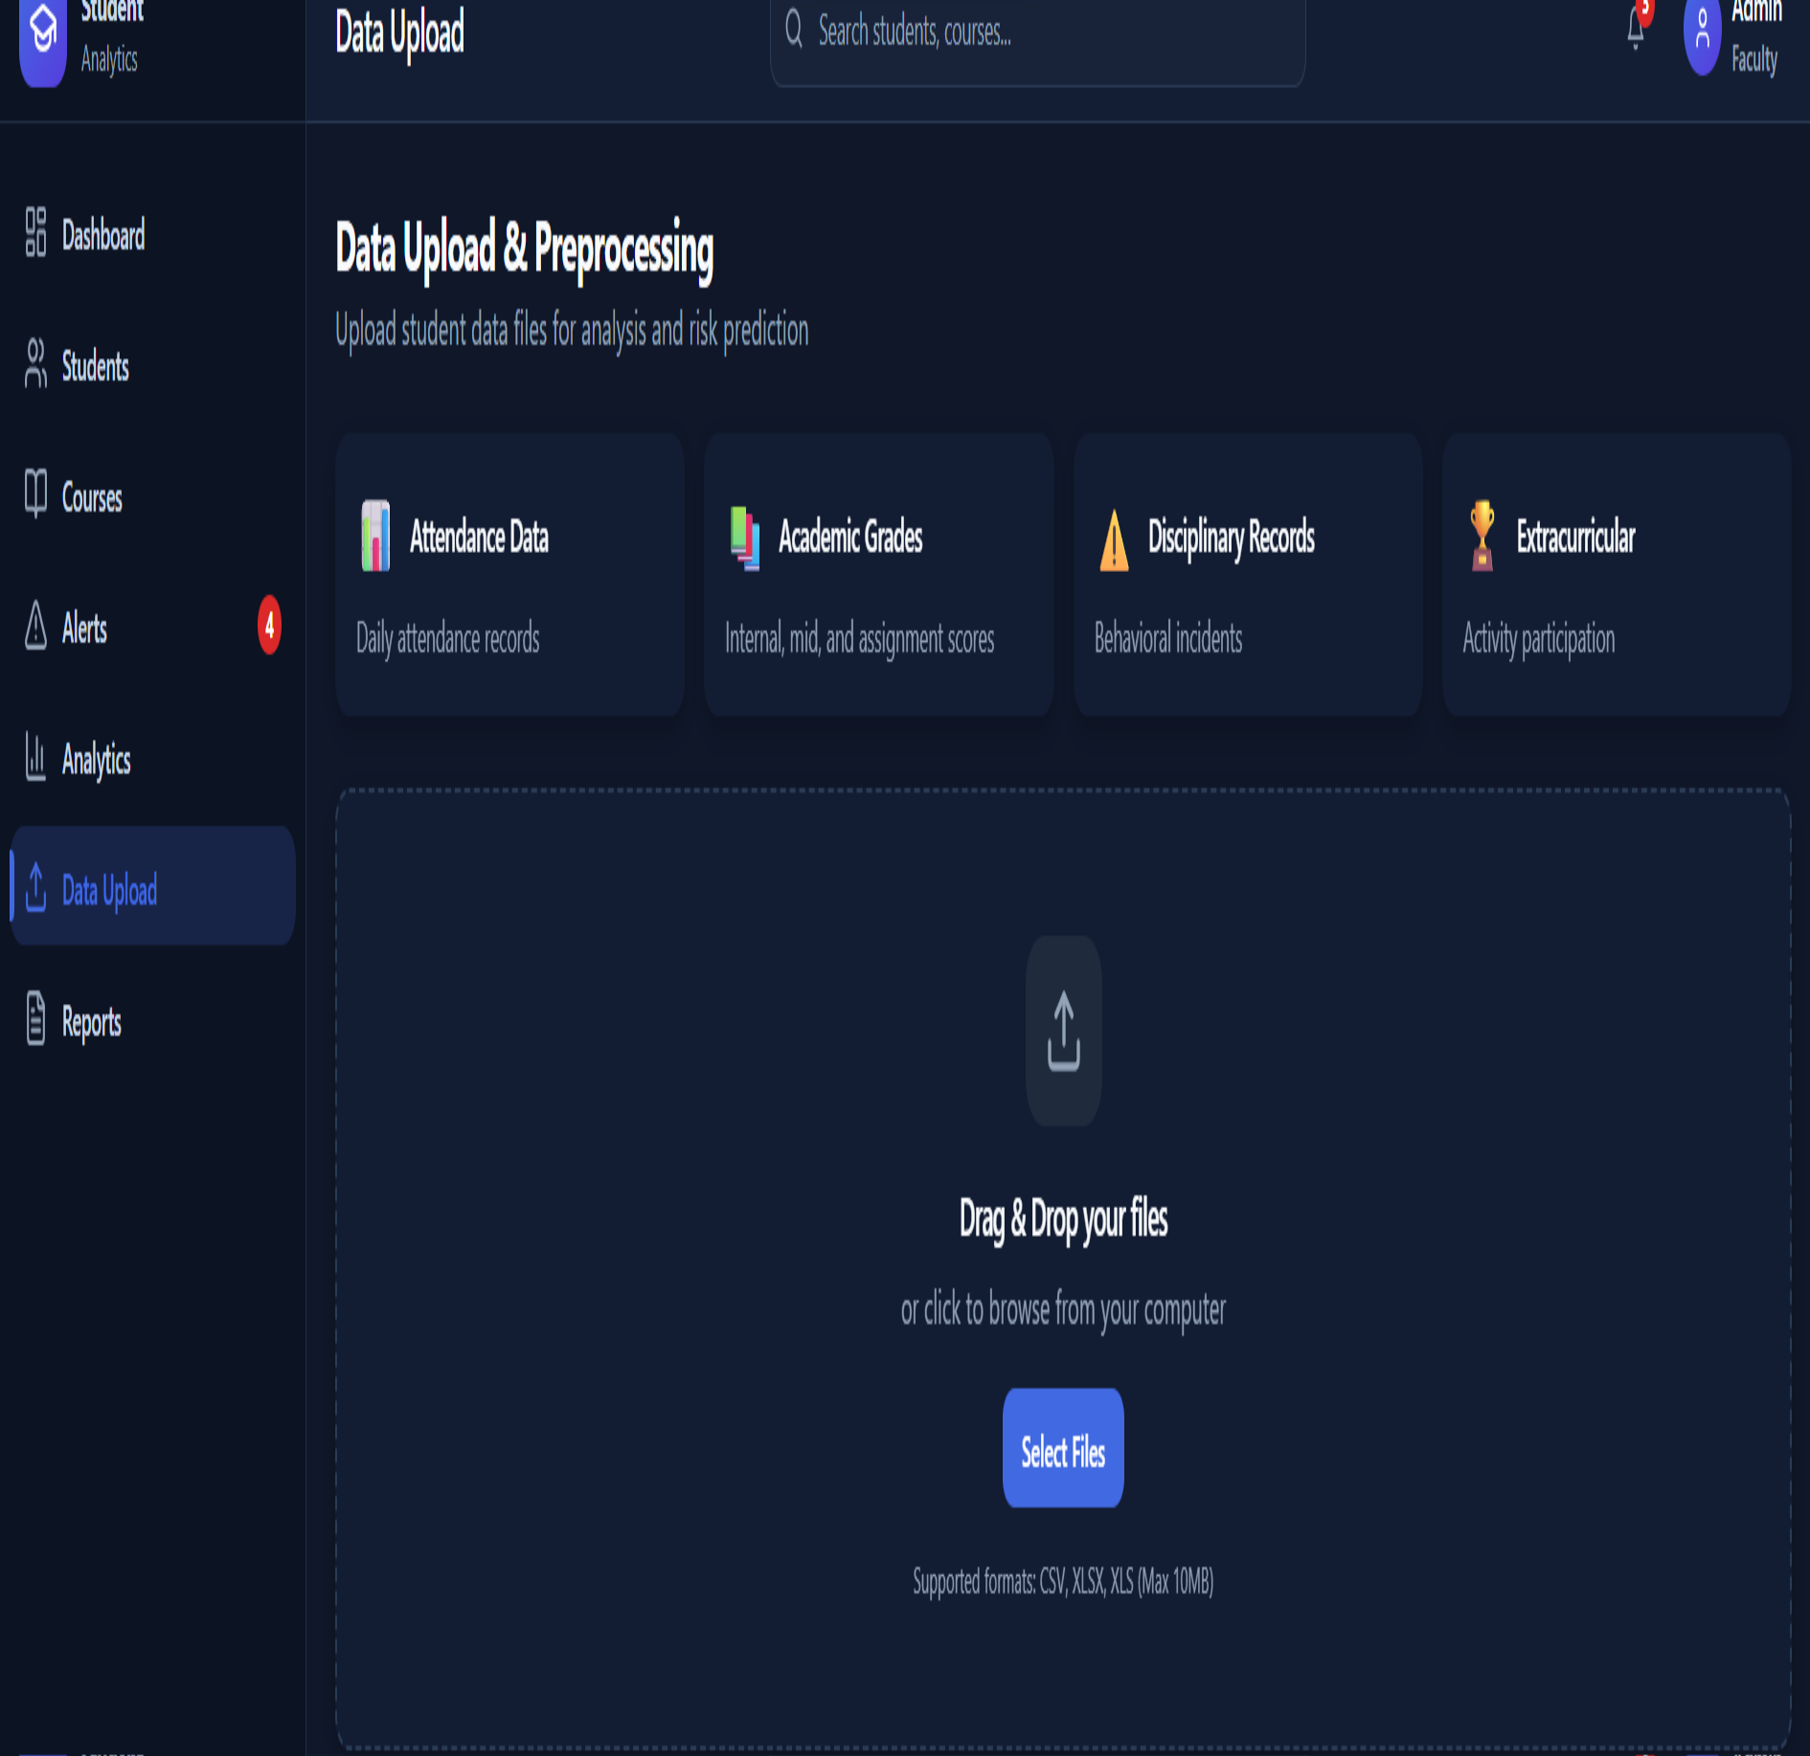

**Postcss.config.js:**

export default { plugins: {

tailwindcss: {}, autoprefixer: {},

}, };

**Output:**

23

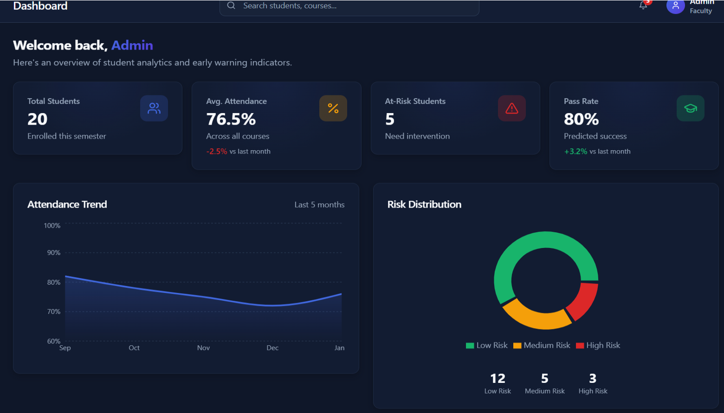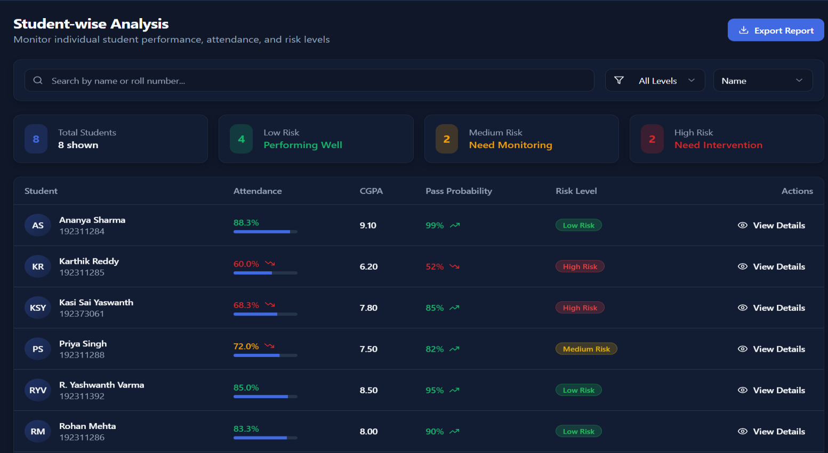

24

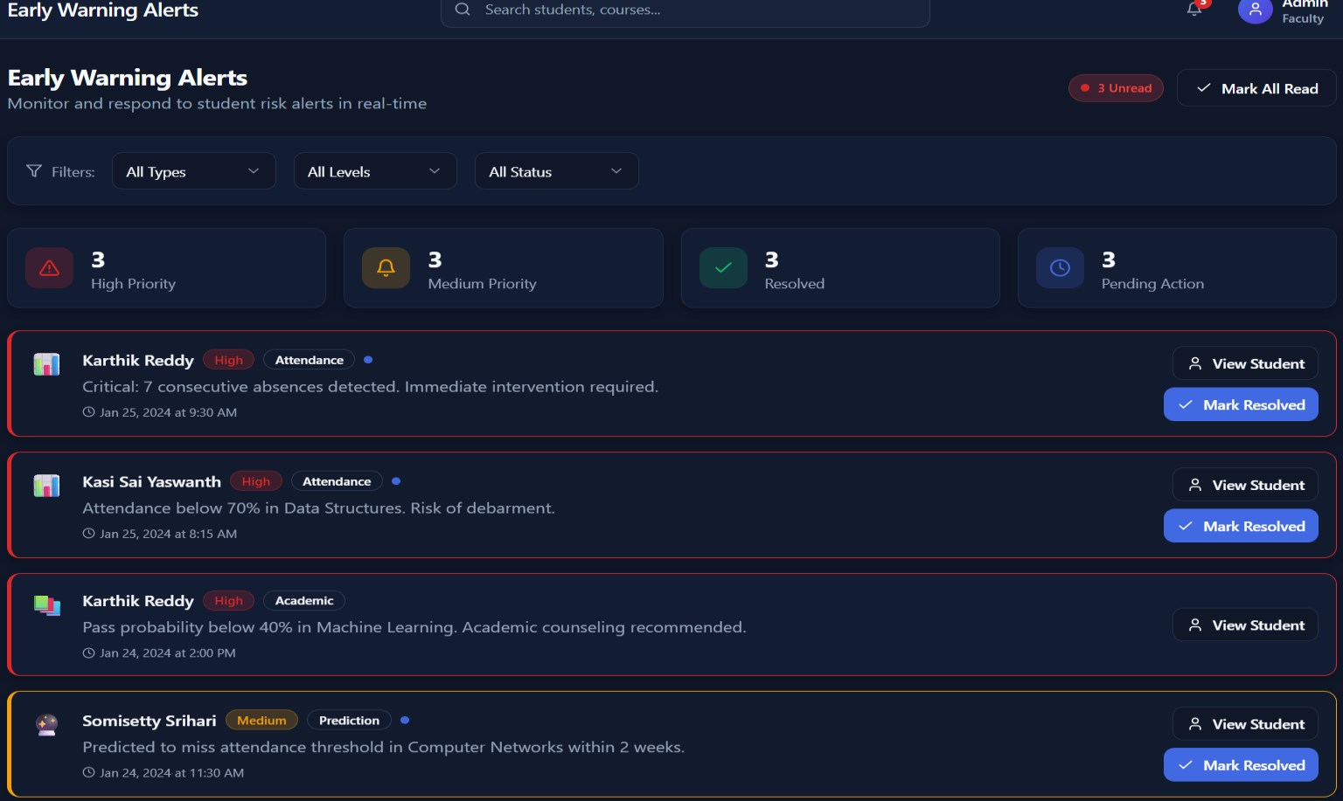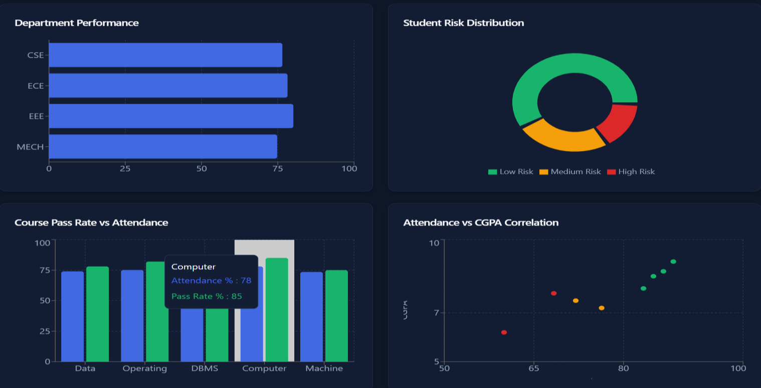

25